press release
(English translation)

INOUT TO HOST THE KEY TALKS AND EVENTS ON TOURISM AND HOSPITALITY
- Over 30 events and talks on the agenda at InOut|The Contract Community, the format created by Italian Exhibition Group in conjunction with TTG Travel Experience, running at Rimini Expo Fair from 9 to 11 October

- Great excitement for the awards, including the ‘Best Beach’ and ‘Golden Compass’ Oscars for beaches

www.inoutexpo.it

Rimini, 9-11 October 2024 – InOut|The Contract Community - the Italian Exhibition Group format dedicated to the entire indoor and outdoor community for tourism and hospitality - will be a prime showcase for the main industry events and talks. Over the three days, scheduled from 9 to 11 October at Rimini Expo Centre, participants will engage in over 30 talks or events on outdoor tourism, hospitality and wellness.

THE MAIN EVENTS AND TALKS
The inauguration of InOut|The Contract Community will run parallel with TTG Travel Experience, with the opening ceremony scheduled for Wednesday 9 October in the Main Arena from 12 to 13.
Here are the key fixtures:

Wednesday 9 October
- Presentation of the exhibition ‘The Infinite Chair’ (Design Arena, Pavilion D3 from 11 to 12pm). The infinite chair is a themed story of the chair as an icon and invention, observing its changes throughout history through the illustrations of architects Elizabeth Francis and Maite García Sanchis.
- Total Outdoor: towards recreating what’s real. The data of open-air hospitality and the new balances between aquatic, natural and indoor environments (Poolwide Arena, Pavilion B2, from 11 to 12pm).

Glamping, camping, tourist villages as well as pool areas, roof gardens, areas for events and sports activities must be rethought according to the guests’ new needs. But where are we at today? And what are the prospects for the next 5 years? At InOut, a number of the industry’s main associations take stock of current events.
- The Golden Compass Award: 70 years in search of remarkability in the design industry. (Design Arena, Pavilion D3 from 2.30 – 3.30pm).
This event created for InOut 2024 and dedicated to professionals in the hospitality industry, including the presentation of the ADI Golden Compass Award - considered the Nobel Prize of Design – describes and remarks on some worthy projects created with a view to responsible and sustainable development.

Thursday 10 October

- Is beauty always true? Overtourism, experience tourism and gentrification: distinguishing false from authentic (BeActive Arena, Pavilion C4, from 11 to 12:30pm). In the eyes of foreign tourists, our country tends to increasingly resemble a gigantic theme park. Is it possible to reverse the trend and give the real Italy back to tourists and residents? Is there a real boundary between authentic and artificial in tourism? At the end of the meeting, organized by Legambiente, the Ecotourism awards ceremony with the Ecotourism Oscars for the best case histories.
- InOut Review Talk, the new trends in hospitality: the truth according to architects (Design Arena, Pavilion D3, from 11 to 12pm) How can we reconcile, in contemporary restyling, the original soul of the structure with contemporary design? What are the architects' solutions to marry these two needs? These are some of the questions that the architects will answer directly, in the panel moderated by Remo Vangelista, director of the magazine InOut Review and of TTG Italia.
- Swimming pools of the future - sustainability, innovation, experimentation and new ways of enjoying them (Poolwide Arena, Pavilion B2, from 11 to 12pm)
Architect Giovanni Giacobone will discuss the challenges the swimming pools of the future will face in terms of sustainability, innovation, experimentation and new ways of enjoying them, and which will change the future of both home and public swimming pools.
- Art and identity. Hoteliers and artists united for distinctive and true hospitality (Design Arena, Pavilion D3, from 4.50 to 6 pm).
Hôtellerie projects require distinctive works of art. Cinquerosso Arte's response is to offer designers and hoteliers works by emerging artists, of the highest quality, respecting the specifications and budgets. An example of the versatility and adaptability of Cinquerosso Arte projects to different environments is the artistic installation in the pool area, inspired by “Veritas”, the theme of the 2024 edition of InOut.
- Ninth edition of the ‘Best Beach’ Oscar (Beach Arena, Pavilion B7-D7, from 4.20 to 5.30 pm).
Best Beach is the first and only national competition dedicated to Italian beaches. Organized by the Mondo Balneare portal in collaboration with InOut, it will elect the winners of the 2024 edition, officially awarding them on the stage of the Beach Arena.
Friday 11 October

The truth about Millennials and Gen Z: young managers speak out. A meeting of minds between those offering and those looking for work (Global Village Arena, Pavilion A2, from 12.10 to 1.10pm).

Those offering work and those looking very often don’t speak the same language. But there is work out there: this is demonstrated by the 300 thousand human resources (from hotel directors to managers to staff positions) that the tourism industry badly needed in summer 2024 and only partially found. The answer will be given by young managers, who have chosen to make a career in the industry, and by HR managers of large companies, who sought out and found the resources.

ABOUT: TTG TRAVEL EXPERIENCE
Event: international trade show; organizer: Italian Exhibition Group SpA; recurrence: annual; edition: 61st; open to: reserved exclusively for trade professionals; website: www.ttgexpo.it - #ttgexpo

PRESS CONTACT IEG, TTG TRAVEL EXPERIENCE
Elisabetta Vitali, head of corporate communication & media relations; Marco Forcellini, Pier Francesco Bellini, press office manager
media@iegexpo.it

MEDIA AGENCY TTG TRAVEL EXPERIENCE
Martina Vacca: martina@mindthepop.it, mob. +39 339 748 4994; Fabrizio Raimondi: fabrizio@mindthepop.it, mob. +39 335 389 848; Benedetto Colli: benedetto@mindthepop.it, mob. 380 371 2272; Stefano Chiossi: stefano@mindthepop.it, mob. + 39 388 739 4358.

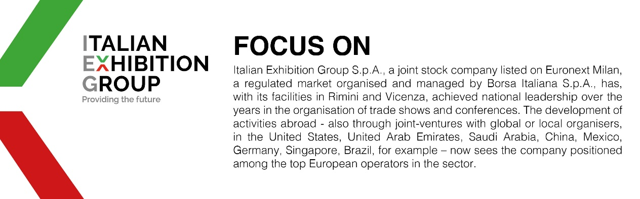

This press release contains forecast elements and estimates that reflect the management’s current opinions (“forward-looking statements”), particularly regarding future management performance, realization of investments, cash flow trends and the evolution of the financial structure. For their very nature, forward-looking statements have a component of risk and uncertainty, as they depend on the occurrence of future events. The effective results may differ (even significantly) from those announced, due to numerous factors, including, only by way of example: food service market and tourist flow trends in Italy, gold and jewellery market trends, green economy market trends; the evolution of raw material prices; general macroeconomic conditions; geopolitical factors and evolutions in the legislative framework. Moreover, the information contained in this release does not claim to be complete, and has not been verified by independent third parties. Forecasts, estimates and objectives contained herein are based on the information available to the Company as at the date of this release.

